# **Online Medicare Channeling System**

# System Documentation

# Group A

Index Numbers

13440293

13440617

## **Introduction**

“Online Medicare System” is a computerized online channeling and patient management system. This management system provide entire functionality required Employees, Doctors, and Patients etc. This project has Web base software which facilitate to insert and retrieve transactions.

Objective of the system:

* Patient should be able to register in the system by them self.
* Scheduling the appointment with doctor make convenient via online.
* Patient should be able to check their channeling history, diagnosis and treatment at each appointment via online web base system.
* Doctors should be able to log in to the system and check their appointments
* Doctors should be able to enter diagnosis information as well as prescription detail for the patients
* Internal staff of the company can obtain channeling information of the patient, Diagnosis detail as well and treatment given at each case using the system.
* Internal staff can use those information to take valuable management decision such as channeling pattern of the patient, how each doctor treat to a patient with same diagnosis etc.
* Increased the productivity and efficiency by managing all the transaction and History data.
* Entering to the doctor and internal staff to the system will be done by admin users.

## **Technology**

System has developed using J2SE, J2EE and component are wired using Spring framework dependency injection features, Hibernate used as a framework for object relational mapping, Maven is used as build tool, and Database is Oracle XE. Thin web base client is implemented using HTML, JSP, Jquery, css and other relevant web base technologies. Final application is package as a .war file and deployed in a jboss EAP 6.4.

## **Assumption**

There is an old existing system which is two tier application. It is possible to expose the services of that existing system as a web services. New online channeling system integrate with old system real time by calling the web service.

## **Architecture of the system**

System can be implement using various architectures such as three Tier, SOA and MVC. Since this is online simple application, it is better to use three tier approach architecture pattern for designing over all architecture of the project.

Final architecture is combination of 3tier SOA as well as MVC. Since we have to integrate with existing system, we decided to come up with JBoss Fuse, lightweight Enterprise Service Bus (ESB). Possible different architecture of implementing this project as follows

**Three tier architecture**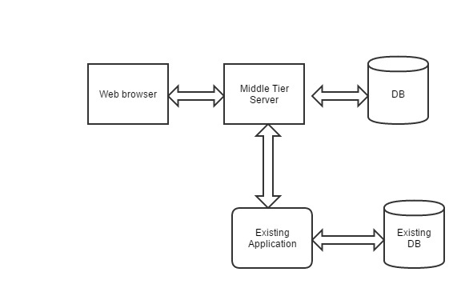

* Here presentation tier is a web browser where customer can directly interact to get the required information as well as functionality like channeling a doctor.
* Middle tier is a business tier which contain the relevant business logic. In this case it process the client request and give and store the required data in the underline DB. This is responsible for handling all the logic related to patients, doctor as well as internal staffs.
* 3rd tier is the data tier. In this case it is the DB base.
* This application can connect with existing application at the business tier using technologies like web services, RMI or CORBA or new application can directly access the DB of the existing application to store and get the required information.

### **SOA Architecture**

This application can be implemented SOA as well.

* Main business of the system can be implemented as independent services such as Patient Management, Doctors management, internal user management, Channel Info management and Medicine Info management. Those modules are independent and can operate independently.
* Service of those individual modules can be expose as web services and can be connected to ESB.
* If we want we can directly call those services through there interfaces rather than going through the ESB.
* Functionality of the old system can be expose are web service or RMI, CORBA service and that also connect to same ESB. In this case it is needed to expose only the services required by online application.
* Those services register in service registry
* Final web application can be created by orchestrating those services in a required manner.

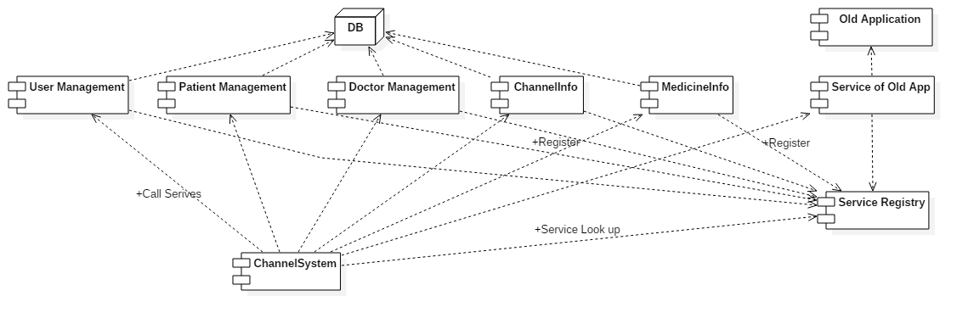

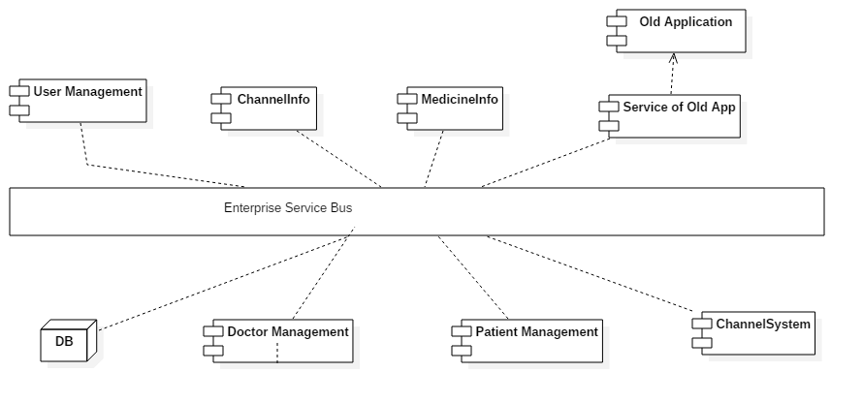

### **MVC Architecture**

This application can be implemented using pure MVC pattern or architecture



View are the web pages created using language like HTML, Java Script and JSP those used to get and display the information to external and internal users of the system such as patient, Doctors and internal staff.

Model part contain the business logic which involve storing the information receive from clients in the system and get the information from DB to serve various kind of client information requests. This can be implemented using pure J2SE or J2EE features like Session bean and entity beans. Also we can use framework like spring, Hibernate to implement the model in nice looking manner. This part is responsible for real time communication with the existing application.

Controller is the one handling the client request and forward them to the relevant area of the model to process them. When it get the reply update those data in view for display purpose. Controller is a java servlet. It can be a pure http servlet implemented from sketch or it can be some things like dispatcher servlet provide by framework like spring.

If we want we can implement the whole application using available MVC framework like Spring MVC, JSF etc.

### Overall Architecture

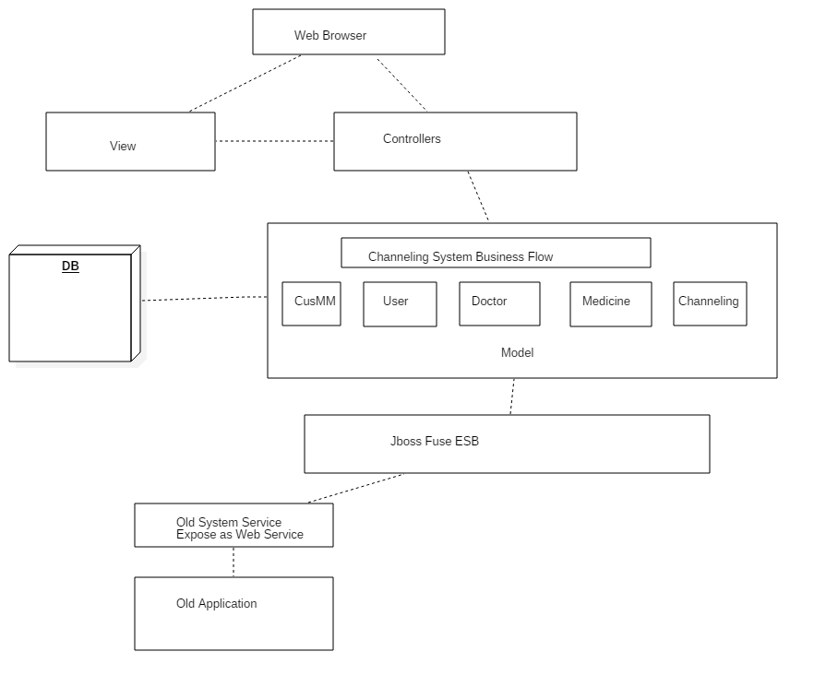

Above diagram illustrate the overall architecture of the online channeling system we develop. It can be consider as a combination of Three Tier, MVC and SOA.

Request from the client of the system coming to the controller those are Java Servlet. Base on the type of the request controllers forward them to the relevant methods of the business flow.

Business Flow responsible for processing the client request with the help of underline modules. Service of the system is divided in to self-contain smaller modules such as Patient Management, Doctor Management, and Channel Info Management etc.

Required services of the old system expose as web service and connected to Jboss Fuse ESB. Inside the work flow of the application this service is used to update the existing system real time.

When the controller get the reply from business flow controller for their request it update the relevant information in the view for displaying purpose.

## **Security**

* All the passwords has encrypted in DB. We use hash mechanism to encrypt the passwords.
* Lock the users account in the case of entering wrong password more than three times
* Two factors authentication is used for log in to the system which use both user name password as well as SMS pin.
* Use https instead of http to encrypt all the data pass between browsers and the server.
* Since hibernate is used as a major techniques of accessing the DB. It is not easy to do the attack like SQL injection.
* Main application is deploy in the internal restricted zone of the network. Proxy server like apache http or nginx hosted in the DMZ zone used as a proxy parser to redirect the request to the main application.
* Web service security can be introduced while exposing the services of the existing application to block the unauthorized access of the services.